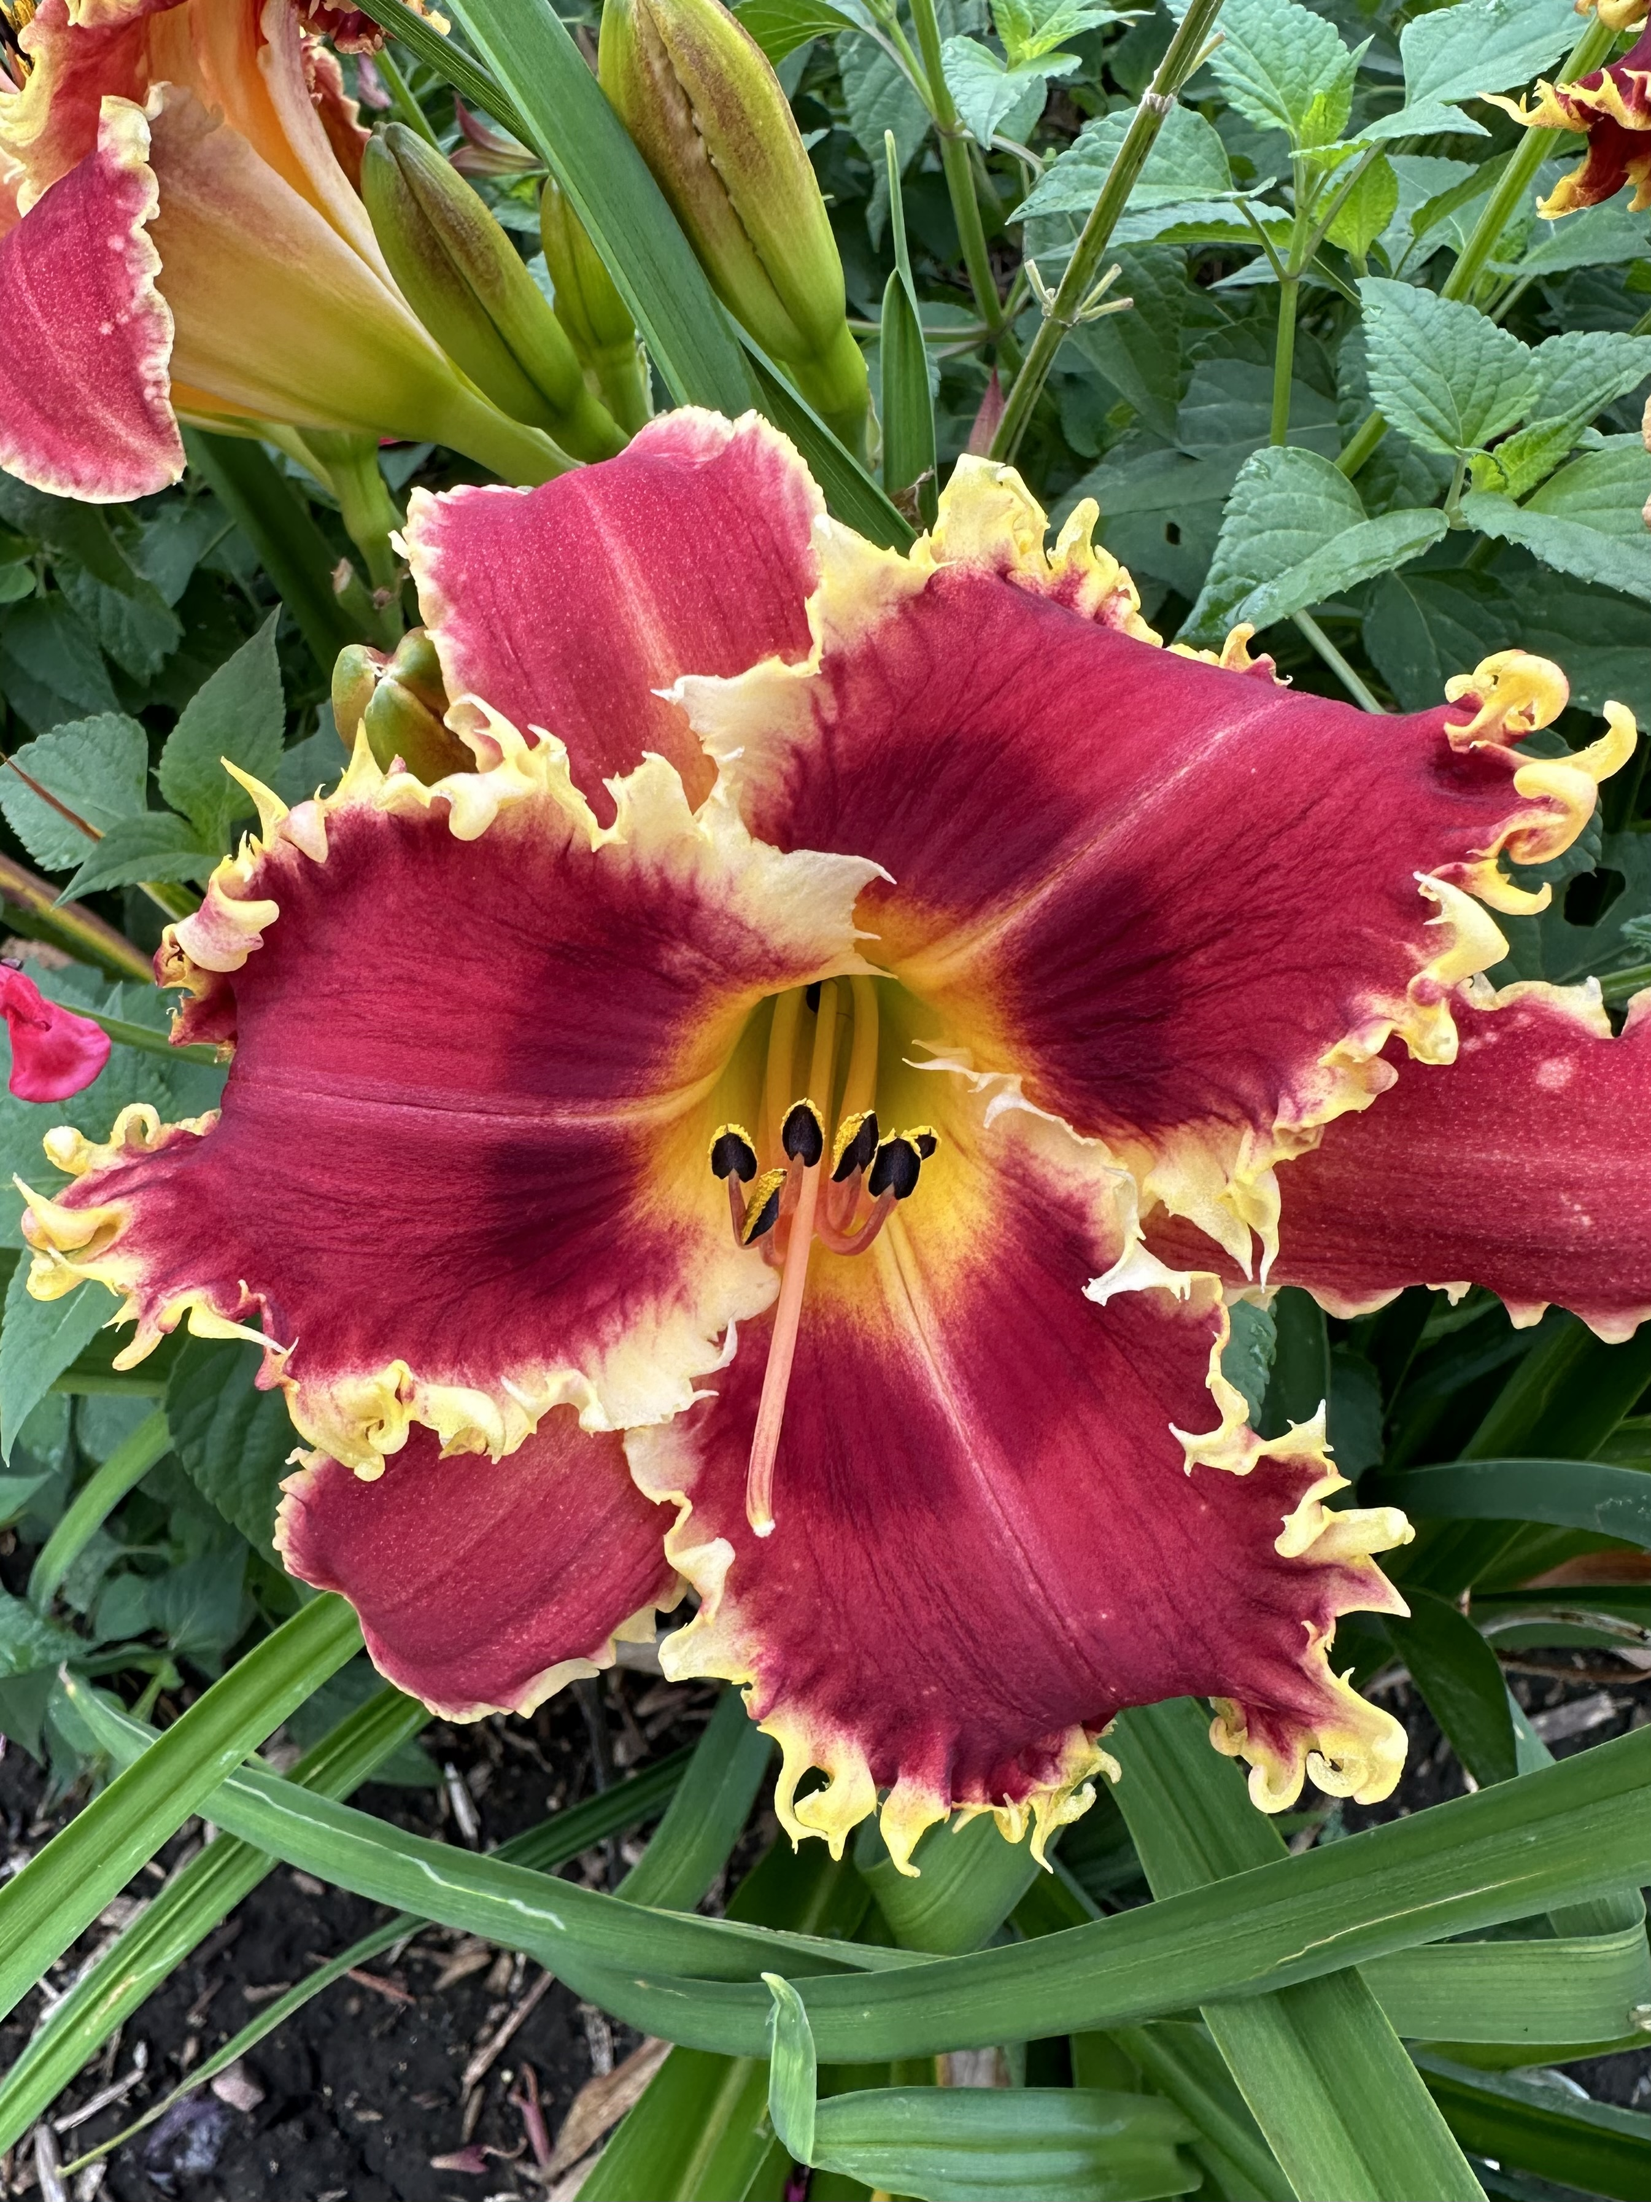
Ruby Red Jubilee
Region One Summer Meeting July 10 – 12 2026
Hosted by Nebraska Daylily Society

Guest Speaker Schedule
Carole Hunter (Prairie’s Edge Daylilies)
Featured Tour Gardens Friday July 10
Hello Gorgeous Gardens – Jenny & Mark Cich 12:00 pm – 4:00 pm Open Gardens (Keller & Roberts’ Gardens)
Lowe Family Gardens – Robin Lowe 12:00 pm – 5:00 pm Registration, Boutique, Silent Auction Open
Lincoln Sunken Gardens 3:00 pm – 3:45 pm Region One Board Meeting
Registration Fee Includes 4:00 pm – 4:45 pm Hybridizers Slides Friday & Saturday dinner and programs, 5:00 pm – 6:00 pm Social Hour/Cash Bar
Saturday Breakfast & Lunch 6:00 pm – 7:00 pm Dinner
Gift Plant with Registration 7:00 pm – 9:00 pm Region One Auction
Guest “Breakfast & Dinner Only” available Saturday July 11
Auction Chair & Mail Plants To 7:00 am – 7:45 am Breakfast at hotel
Butch Ahlers 308- 357-1291 7:45 am Buses Depart
16270 N. Macon Road 3:40 pm Buses Return
Belgrade, Ne 68623-5145 3:45 pm – 5:00 pm Boutique & Silent Auction butchahlers@gmail.com 5:00 pm – 6:00 pm Social Hour/Cash Bar
Registrar 6:00 pm – 7:00 pm Banquet
Henri Schiphorst 402-960-4892 7:00 pm – 7:30 pm Region One Business Meeting
405 Center St. 7:30 pm – 8:30 pm Guest Speaker – Carole Hunter
Oakland, IA 51560 8:30 pm – 8:45 pm Invitation to 2027 Regional
hschip@frontiernet.net
Hotel Sunday July 12
Lincoln Marriott Cornhusker 10:00 am – 12:00 pm GJW2* at Pick A Daylily Garden 333 S 13th St, Lincon, NE (Scott Keller’s Garden)
Reservation-Link or 1-888-236-2427 10:00 am – 12:00 pm Open Garden (Scott Keller’s Garden)
Reservations Group Rate - $143 (Parking Included) *Preregister for Garden Judges Workshop 2 by June 10, 2026*
Until June 12, 2026 *Contact Val Hoefer if you have questions about GJW2*
Mention NEBRASKA DAYLILY SOCIETY
Questions contact Val Hoefer 402-843-0349 / hoefrv@gmail.com

Registration Form 2026 Region One Summer meeting

Make checks out to NDS and mail with form to NDS, 405 Center St. Oakland, IA 51560

Name(s)______________________________________________________________________________________________
List names as you would like on name tags ( Mark Y after name for Youth)
Address________________________________ City_______________ State_____ Zip________ Telephone______________
Email______________________________ Special needs__________________________ Diet_________________________
Will you accept email confirmation? Yes_____ No_____
#Adults________________ postmarked by June 10, 2026 $180______________________
#Adults________________ postmarked by June 15, 2026 $220______________________
#Youths________________ $ 85 ______________________
Guest Meals Only (indicate # of guests per meal) Friday Dinner $60______ Sat. Breakfast $30_____ Sat. Dinner $60______
Total Fees $_________________________

Name attending GJW2____________________________________________

